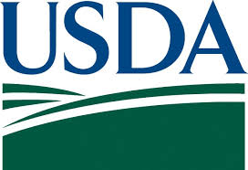 |  | 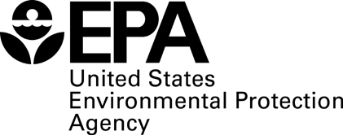

U.S. Food Loss and Waste 2030 Champions Activity Form

(Compass Group) will strive to reduce food loss and waste in its operations by 50 percent by 2030 through activities targeting the prevention of food loss and waste before it arises, recovery of wholesome, otherwise wasted food for donation, and recycling of food loss and waste to other uses such as animal feed, compost and energy generation.

(Compass Group.) will report periodically on its progress on meeting its goal on its website at (https://www.compass-usa.com/.)

Specific food loss and waste reduction activities include:

Compass Group is driving change from the inside out with a landmark commitment to reduce food waste by 25% by 2020. We created a global movement with our international day of action called Stop Food Waste Day. Endorsed by Natural Resources Defense Council, Save the Food and celebrity chef Tom Colicchio, Stop Food Waste Day was created to raise awareness of the global issue surrounding food waste. In 2018, Stop Food Waste Day celebrations were hosted in 34 countries worldwide. To track and measure food waste in our kitchens, Compass Group chefs utilize a proprietary web-based tool called Waste Not. Waste Not provides a detailed level of awareness and reporting capabilities for our sites to be more efficient. In situations where we have excess food that cannot be repurposed, we engage with our food recovery partners across the country to donate the food to a local organization. We have also created the Imperfectly Delicious Produce (IDP) program to rescue "ugly" fruits and vegetables from going to the landfill.

Point of Contact:
Name of Business:
Email:
Date: | April 3, 2019

Please return this form to FoodWasteChallenge@oce.usda.gov or Ms. Lana Suarez of the EPA at suarez.lana@epa.gov.

The 50-percent reduction could be calculated on an absolute or per customer/consumer basis. In addition, the exact definition of food loss and waste could vary by country, business and consumer. The Food Loss and Waste Protocol provides information on defining and transparently measuring food loss and waste. Businesses are also invited to join the EPA’s Food Recovery Challenge to access technical assistance for measuring food waste and assessing the positive environmental benefits of waste reduction.
Businesses that are not ready to make the 50-percent reduction commitment but are engaged in efforts to reduce food loss and waste in their operations can be recognized for their efforts by either joining the EPA’s Food Recovery Challenge or USDA’s U.S. Food Waste Challenge. Businesses that join the EPA’s Food Recovery Challenge will be able to access technical assistance to help set their own quantitative food-waste goals and to measure waste reduction. Businesses that join USDA’s Food Waste Challenge share information on their activities to reduce, recover and recycle food loss and waste in their operations to help disseminate information on best practices and stimulate more of these activities.

